PICTURE QUALITY CHECK TUTORIAL

Script explanation and input/output handling
  - Inputs: ids.text // assignament.csv // clients.csv // intermediate_output.csv
  - Outputs: intermediate_output // final_output.csv
  - Scripts: get_ids.py // process_images.py

- In the script process_images.py fill username and password with Upya personal login
- Do the same thing in get_ids.py
- Download from Upya and store in the folder the csv files assignament.csv and clients.csv (these must be the names)
- Fill the file ids.txt: vector with all the client numbers. Copy the client numbers from the Excel file that you have used to download from Upya so far in order to perform the quality check (ASSIGNMENT FORM).
- Run the script get_ids.py: Open the terminal (as you did in 2.a) and run this command:
python .\get_ids.py
  - Wait until it performs all iterations (it may take a couple of hours, don’t worry)
  - The output of script is the csv file intermediate_output.csv. It looks like this:
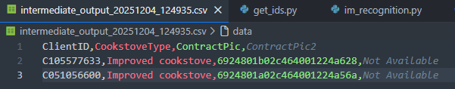
- Run the script process_images.py: in the terminal run this command:
python .\im_recognition.py
  - Wait until it performs all iterations (it may take hours, don’t worry)
  - Its inputs are the latest intermediate_output.csv created/updated, assignament.csv and clients.csv
  - Its output (and final output ready to be post-checked manually and sent to the field operators) is final_output.csv. It looks like that:
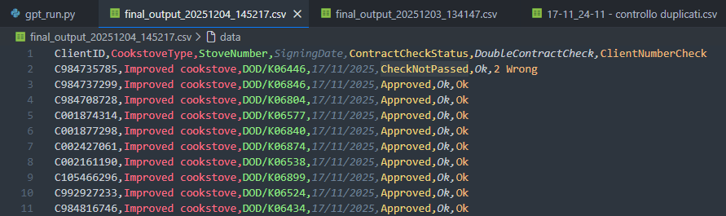

How to understand the Output:
- ContractCheckStatus can be:
  - IDNotFoundInCSV = there’s no picture
  - NoValidUrlGenerated = there’s error message
  - NoCorrectDownload = there’s error message (it shouldn’t happen anymore actually)
  - CheckNotPassed = the picture is present, but it is not the right one
  - Approved = picture present and correct
- DoubleContractCheck can be:
  - Double Contract = the client has 2 or more assignment form
  - Ok = the client has only one assignment form
- ClientNumberCheck aims to find out mis taken identities. It can be:
  - 2 Wrong = the problem in the picture is that the ClientNumber doesn’t match the one on upya
  - Ok = the problem in the picture is not the ClientNumber

